**Online Library Management System Guideline**

**What You need?**

* Microsoft Visual Studio Community 2019
* Microsoft SQL Server Management Studio 18
* SQL Backup database file.

**What Include in folder?**

* Main Project File **LibraryApplication** and database backup file **MyLibDB.bak .**

**1). How to import backup file into Microsoft SQL Server Management Studio 18?**

* Open Microsoft SQL Server Management Studio 18 and Click On connect button Showing Below.

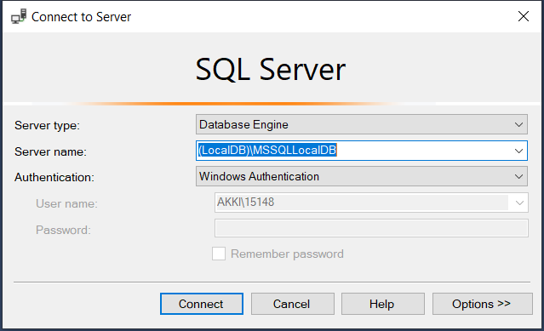

* Then Create new Database and Save it. Right-click on New database that you made it and click on Tasks and Select Restore 🡪 Database.

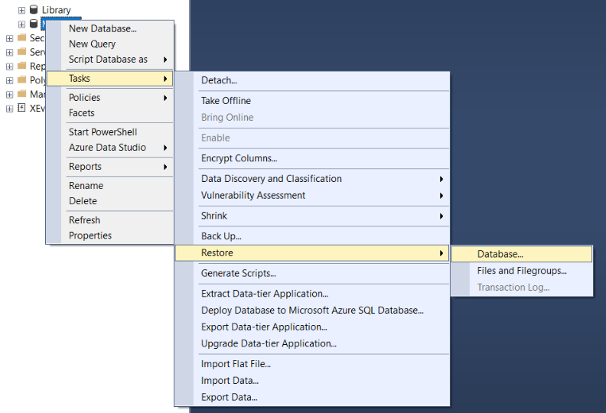

* Then Select Option and click on Mark that is showing in to picture. After that select general.

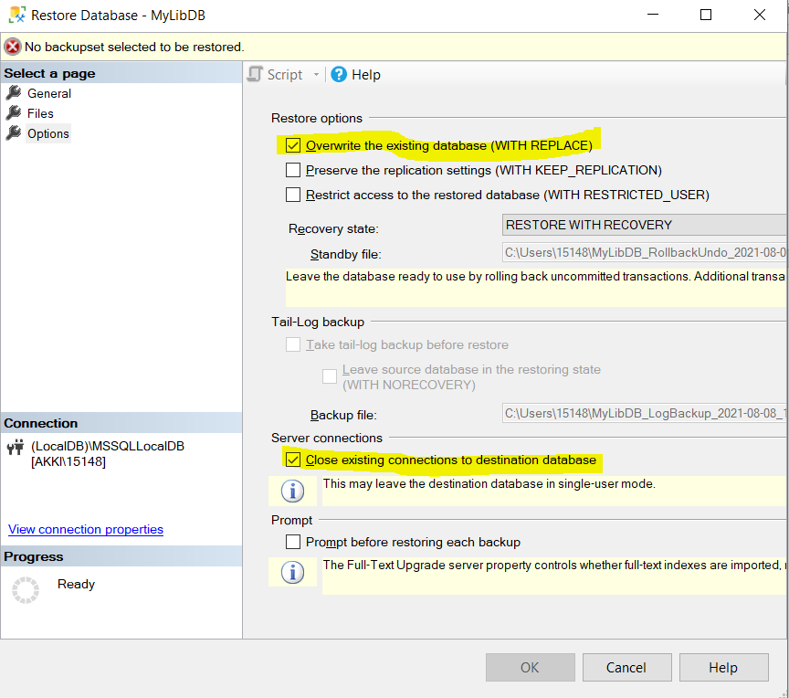

* Select Device and click on database that you created and click on Add and select backup file of database where you download your data and click ok. And again ok. Again ok. It will show you backup database added successfully.
* That is how you import database.

**2). How to run program in Microsoft Visual Studio 2019.**

* Once you install Community version you have to add few workloads to your visual studio.
  + ASP.NET and web development
  + .NET desktop development
  + .NET cross-platform development
* Import project file and click on IIS Express and then you can watch bottom video how the project is.
* Here is the Video Guideline how project will run.

[**https://drive.google.com/drive/folders/1wTnDHhxAscn0Qo2bmL0LRE7GIA5H7Sdu?usp=sharing**](https://drive.google.com/drive/folders/1wTnDHhxAscn0Qo2bmL0LRE7GIA5H7Sdu?usp=sharing)